
W-16
11 PHYSICS ATAR
TEST 4: ELECTRICITY

NAME: MARK: 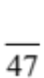

1. The diagram below represents a cathode ray tube that accelerates electrons between its electrodes. Each second, 3.12 x 10² electrons move between electrodes X and Y. The accelerating voltage is 5.00 x 10² V.

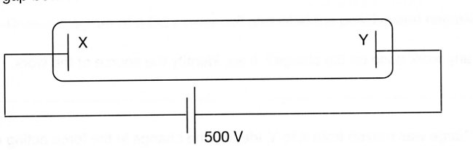

(a) On the diagram, draw the direction of the electric field in the tube. Explain why you chose this direction.

(2)
(b) Determine the size of the current that flows.

(3)

(c) Calculate the speed of the electrons as they reach the opposite electrode.

(3)

(d) What is the power developed by the power source of the tube?

(3)

2. What is the cost of running a 5.50 x 10² W refrigerator for a year if it operates an average of 8.25 hours per day and electricity costs 26.5 cents per unit?
(1.00 unit = 1.00 kWh = 3.60 x 10⁶ J)

(3)
3. How much heat energy is dissipated by a 48.0 kΩ resistor that has a current of 0.350 A flowing through it for a time of 40.0 minutes?

(4)

4. Determine the total resistance in each of the simple circuits shown below.
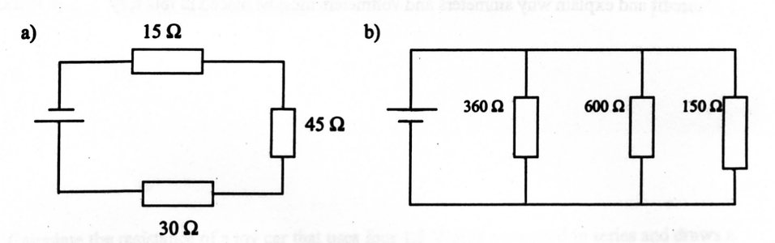

(5)
5. Describe how the following act as safety features to protect people from electric shock.

(a) Fuse

(b) Earth wire

(c) Double insulation

(3)

6. The circuit below shows a complex circuit with 25.0 mA of current flowing in the 100 Ω resistor C.
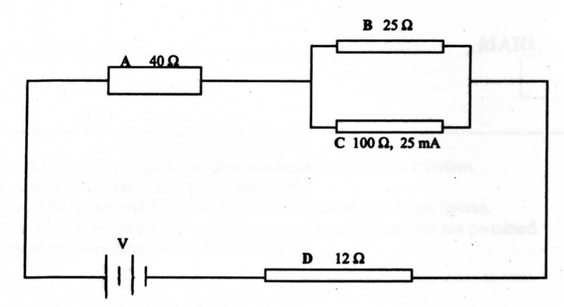

(a) Find the potential difference across resistor C.

(2)
(b) What is the current flowing in resistor B?

(2)
(c) Determine the total current flowing in the circuit.

(2)

(d) What is the effective resistance of the circuit?

(3)
(e) What is the potential difference of the electricity source?

(2)

7. A group of students were given the task of determining the value of an unknown ceramic resistor. Their results were as follows.

Voltage (V) | Current (A)
1.95 | 0.75
3.80 | 1.55
6.15 | 2.50
8.00 | 3.10
9.85 | 4.00

(a) Draw a circuit diagram to show how the students would measure the voltage and current through the resistor.

(3)

(b) Graph these results on the grid provided.
(4)

(c) Determine the gradient of the graph and hence the value of the resistance.

(3)

